## **Lab_Day-3 ANP-C9180 (Programming Statements)**

1. Using input() function takes one number from the user and using ternary operators check whether the number is even or odd .

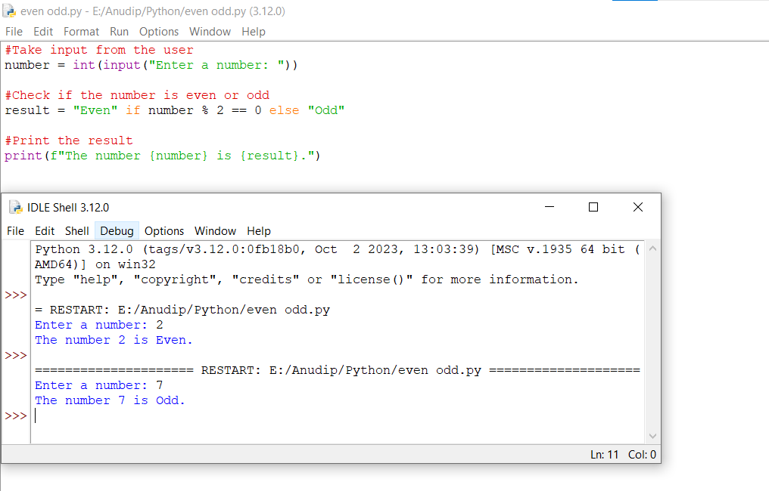

2. Using input function take two number and then swap the number

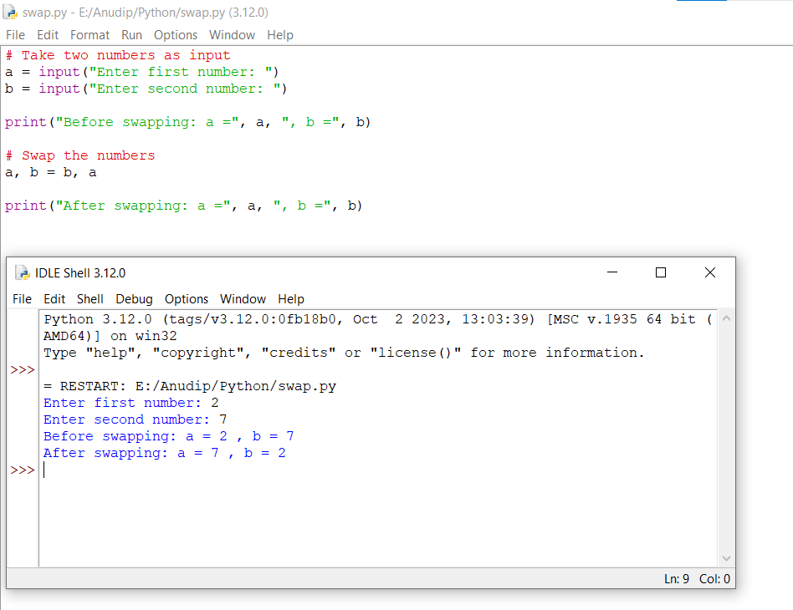

3. Write a Program to Convert Kilometers to Miles

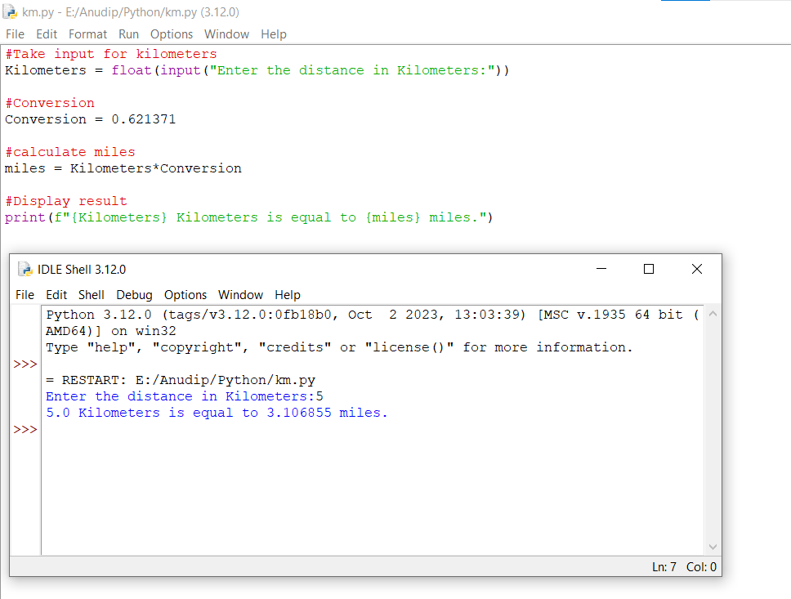

4. Find the Simple Interest on Rs. 200 for 5 years at 5% per year.

